=========== 28/12, Sprint 5, First Week Report ===============

**Time:** 9:10

**Team members present:**

* Ngũ Kiệt Hùng
* Nguyễn Thế Thanh Long
* Trình Cao An
* Trần Thanh Long
* Trần Nguyễn Nhật Cường

**Team members absent:**  None

**JIRA status:**

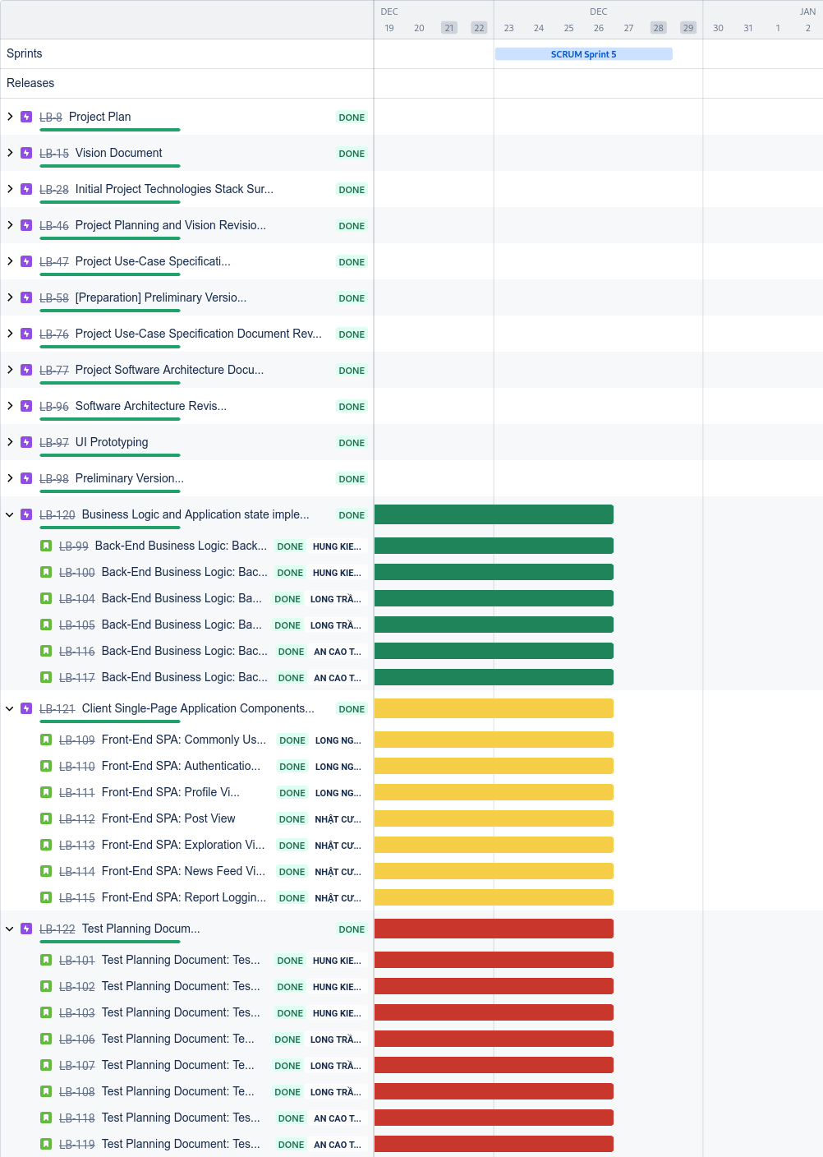

**Status reports:**

* Ngũ Kiệt Hùng
  + Completed tasks
    - *Test Planning Document:* Testing Responsibilities, Staffing, and Training Needs
    - *Test Planning Document:* Testing Results
  + To-do tasks: None
  + Issues/Obstacles:
    - Examination week schedule continues to stagger progress.
* Trình Cao An
  + Completed tasks: None
  + To-do tasks: None
  + Issues/Obstacles
    - Missing communication with other integration members due to examination week.
* Trần Thanh Long
  + Completed tasks
    - *Test Planning Document:* Testing Features Test Cases design and specifications
  + To-do tasks: None
  + Issues/Obstacles:
    - Examinations stagger progress.
* Trần Nguyễn Nhật Cường
  + Completed tasks:
    - *Front-End SPA:* Post View
    - *Front-End SPA:* Exploration View
    - *Front-End SPA:* Report Logging View
  + To-do tasks: None
  + Issues/Obstacles
    - UI integration with back end is impossible since the required logical service is incomplete
* Nguyễn Thế Thanh Long
  + Completed tasks:
    - *Front-End SPA:* Profile View
  + To-do tasks: None
  + Issues/Obstacles :
    - Lack of communication to clarify UI requirements.
    - Lack of communication to back end service implementation team.

**Actions:** The meeting had been conducted to allow team members of different implementation parts to catch up with the source code and logical flow of the system. The team management also takes the remaining time budget to follow up with deployment on single and multi machine environments.

**Summary of the meeting:** the meeting is the final meeting of this phase of the project. Due to foreseen but unresolved issues, team members were not able to deliver a more complete system. The deliverable of the phase is suitable based on minimum viable product requirements and to act as a pitching tool to present to stakeholders.

=========== 21/12, Sprint 5, First Week Report ===============

**Time:** 14:52

**Team members present:**

* Trình Cao An
* Trần Thanh Long
* Trần Nguyễn Nhật Cường
* Ngũ Kiệt Hùng

**Team members absent:**

* Nguyễn Thế Thanh Long

**JIRA status:**

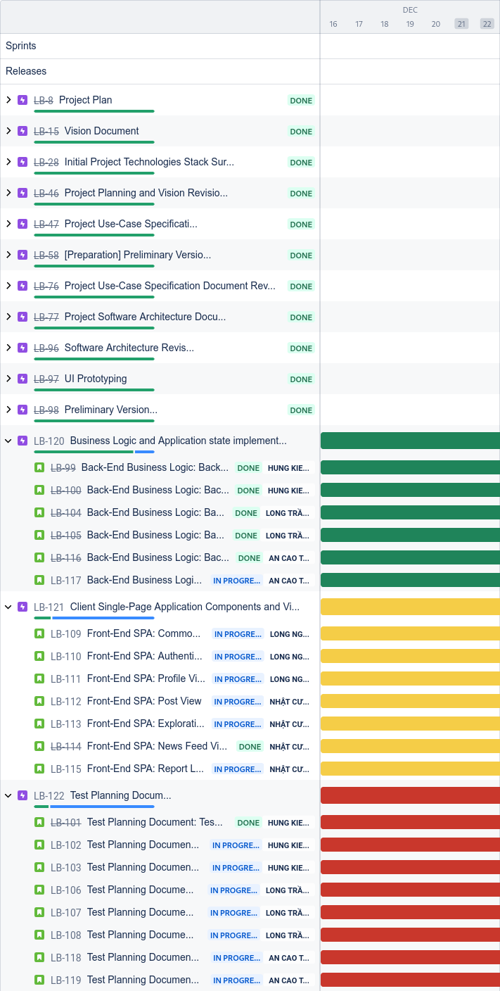

**Status reports:**

* Ngũ Kiệt Hùng
  + Completed tasks
    - *Back-End Business Logic:* Back-End Controllers
    - *Back-End Business Logic:* Back-End Authentication Service
    - *Test Planning Document:* Test Plan Introduction
  + To-do tasks
    - *Test Planning Document:* Testing Responsibilities, Staffing, and Training Needs
    - *Test Planning Document:* Testing Results
  + Issues/Obstacles:
    - Examination week schedule is staggering progress.
* Trình Cao An
  + Completed tasks
    - *Back-End Business Logic:* Back-End Post Service
    - *Back-End Business Logic:* Back-End Administration Service
    - *Test Planning Document:* Testing Areas
    - *Test Planning Document:* Testing Techniques
  + To-do tasks: None
  + Issues/Obstacles
    - No data logic to implement sub system integration due to back end subsystem not completed yet.
* Trần Thanh Long
  + Completed tasks:
    - *Back-End Business Logic:* Back-End Profile Service
    - *Back-End Business Logic:* Back-End Feeds Generation Service
    - *Test Planning Document:* Testing Features
    - *Test Planning Document:* Testing Environment Needs specification
  + To-do tasks
    - *Test Planning Document:* Testing Features Test Cases design and specifications
  + Issues/Obstacles:
    - Examinations stagger progress.
* Trần Nguyễn Nhật Cường
  + Completed tasks:
    - *Front-End SPA:* News Feed View
  + To-do tasks
    - *Front-End SPA:* Post View
    - *Front-End SPA:* Exploration View
    - *Front-End SPA:* Report Logging View
  + Issues/Obstacles
    - UI design does not matches initial design due to not being familiar with the modeling language, as well as constraint on time.
* Nguyễn Thế Thanh Long
  + Completed tasks:
    - *Front-End SPA:* Commonly Used Components
    - *Front-End SPA:* Authentication View
  + To-do tasks
    - *Front-End SPA:* Profile View
  + Issues/Obstacles :
    - Lack of communication to clarify UI requirements.

**Actions:** Based on the current progress, the team has decided to allocate more time (even afterhours) to speed up the implementation process and to start specifying test cases.

**Summary of the meeting:** the first meeting of the final Sprint has concluded with many tasks at hand that are yet to be completed. With the current progress, although over half of the workload is finished, many small implementation details are clogging up other tasks of the whole team. Despite that, we have found temporary solutions to address the issue.

=========== 14/12, Sprint 4, Second Week Report ===============

**Time:** 20:36

**Team members present:**

* Ngũ Kiệt Hùng
* Trình Cao An
* Trần Thanh Long
* Nguyễn Thế Thanh Long
* Trần Nguyễn Nhật Cường

**Team members absent:** None

**JIRA status:**

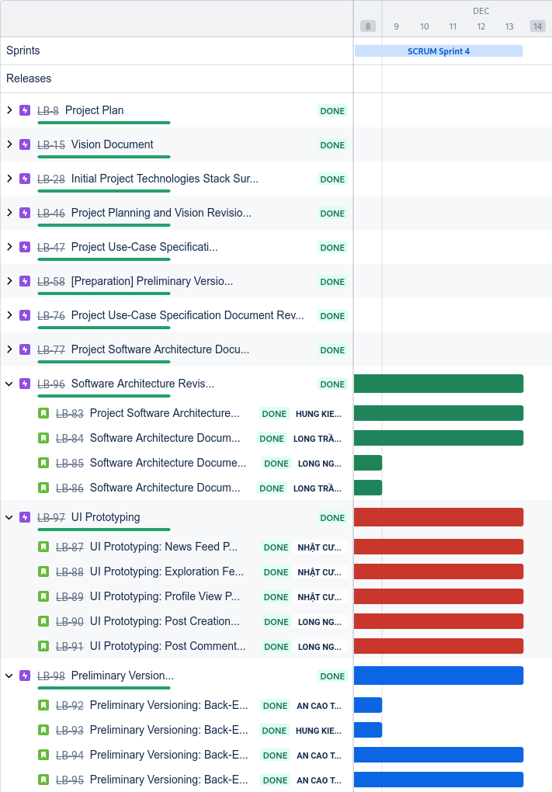

**Status reports:**

* Ngũ Kiệt Hùng
  + Completed tasks
    - *Software Architecturing:* Review and correction based on stakeholder’s feedback.
  + To-do tasks
    - Prepares for PA5
  + Issues/Obstacles: None
* Trình Cao An
  + Completed tasks: None
  + To-do tasks
    - Prepares for PA5
  + Issues/Obstacles: None
* Trần Thanh Long
  + Completed tasks
    - *Software Architecturing:* Project deployment state and diagram (Minimum of 3 nodes in the diagram).
    - *Software Architecturing:* Project Implementation file structure for Back-end Subsystem.
  + To-do tasks
    - Prepares for PA5
  + Issues/Obstacles: None
* Trần Nguyễn Nhật Cường
  + Completed tasks
    - *UI Prototyping:* News Feed Page.
    - *UI Prototyping:* Exploration Feed Page UI prototyping.
    - *UI Prototyping:* Profile View Page UI prototyping.
  + To-do tasks
    - Prepares for PA5
  + Issues/Obstacles:
    - Late feedback from the team.
* Nguyễn Thế Thanh Long
  + Completed tasks
    - *UI Prototyping:* Post Creation Dialogue UI prototyping.
    - *UI Prototyping:* Post Commenting Dialogue UI prototyping.
  + To-do tasks
    - Prepares for PA5
  + Issues/Obstacles

**Actions:** Preparation for PA5 tasks is undergoing. The team has finalized on the systems architecture and implementation is in progress.

**Summary of the meeting:** the meeting has verified the completion of tasks of team members during this Sprint. Many problems such as lack of time budget to expand UI prototyping to a more user-friendly UX has ground the team from achieving early completion of some non-functional requirements. But overall, the progress is looking fine.

=========== 08/12, Sprint 4, First Week Report ===============

**Time:** 20:44

**Team members present:**

* Trình Cao An
* Trần Thanh Long
* Nguyễn Thế Thanh Long
* Trần Nguyễn Nhật Cường
* Ngũ Kiệt Hùng

**Team members absent: None**

**JIRA status:**

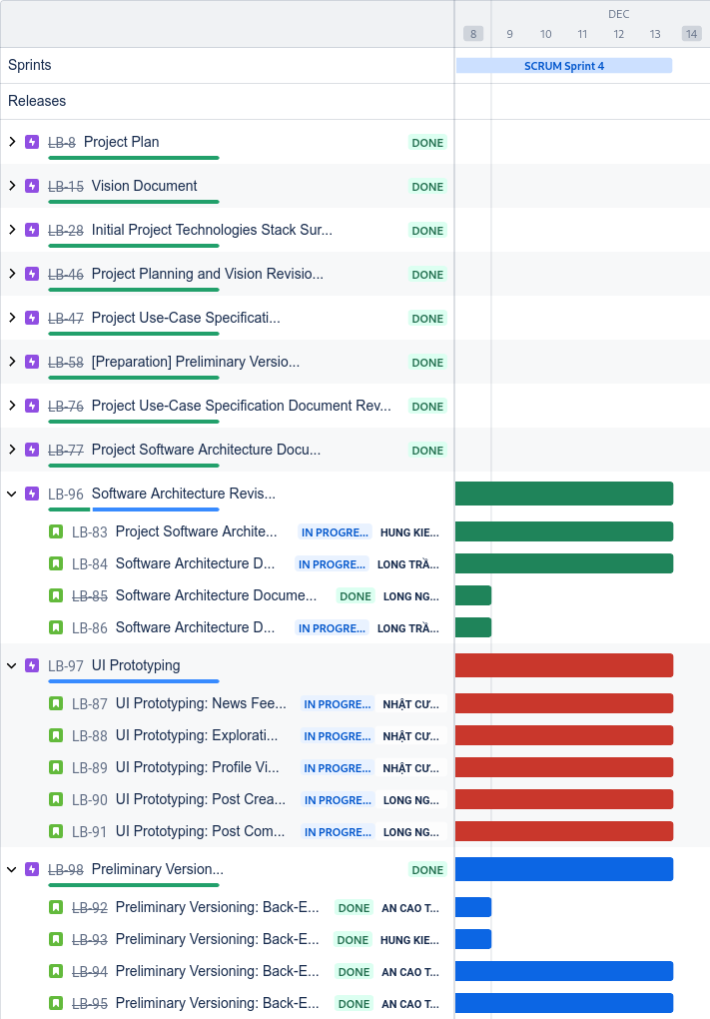

**Status reports:**

* Ngũ Kiệt Hùng
  + Completed tasks
    - *Preliminary Versioning:* Back-End Database Setup.
  + To-do tasks
    - *Software Architecturing:* Review and correction based on stakeholder’s feedback.
  + Issues/Obstacles:
    - No feedback from stakeholders yet.
* Trình Cao An
  + Completed tasks
    - *Preliminary Versioning:* Back-End Business Logic for user’s profile information retrieval and update from/to database
    - *Preliminary Versioning:* Back-End Business Logic for block post information retrieval and update from/to database
    - *Preliminary Versioning:* Back-End Components boilerplating and data classes implementation.
  + To-do tasks: None
  + Issues/Obstacles
    - Java projects, specifically built with Spring, have strange, imposed file structuring that needs documentation reading to clear up.
* Trần Thanh Long
  + Completed tasks: None
  + To-do tasks
    - *Software Architecturing:* Project deployment state and diagram (Minimum of 3 nodes in the diagram).
    - *Software Architecturing:* Project Implementation file structure for Back-end Subsystem.
  + Issues/Obstacles:
    - Deadlines from other courses hinder progress.
* Trần Nguyễn Nhật Cường
  + Completed tasks: None
  + To-do tasks
    - *UI Prototyping:* News Feed Page.
    - *UI Prototyping:* Exploration Feed Page UI prototyping.
    - *UI Prototyping:* Profile View Page UI prototyping.
  + Issues/Obstacles
    - UI design toolings are not familiar to Cường and more time is needed for him to get used to it.
    - UI ideas change rapidly, causing many rewrites and unnecessary conflicts.
* Nguyễn Thế Thanh Long
  + Completed tasks:
    - *Software Architecturing:* Project Implementation file structure for Front-end Subsystem
  + To-do tasks
    - *UI Prototyping:* Post Creation Dialogue UI prototyping.
    - *UI Prototyping:* Post Commenting Dialogue UI prototyping.
  + Issues/Obstacles :
    - UI design toolings are not familiar to Long and more time is needed for him to get used to it.
    - Lack of communication to clarify UI requirements.

**Actions:** Based on the current progress, the team has decided to speed up the workload and planning scripts to describe the usage of UI elements.

**Summary of the meeting:** the meeting has found progress in the Sprint’s timeline. Although the progress is still not aligned with what management has planned, it is still in an acceptable range for which members who have not submitted their work have ensured it will be done. Moreover, team members are mostly inexperienced with the toolings used in this Sprint, but progress has been found in getting used to it.

=========== 30/11, Sprint 3, Second Week Report ===============

**Time:** 20:20

**Team members present:**

* Ngũ Kiệt Hùng
* Trình Cao An
* Trần Thanh Long
* Nguyễn Thế Thanh Long
* Trần Nguyễn Nhật Cường

**Team members absent:** None

**JIRA status:**

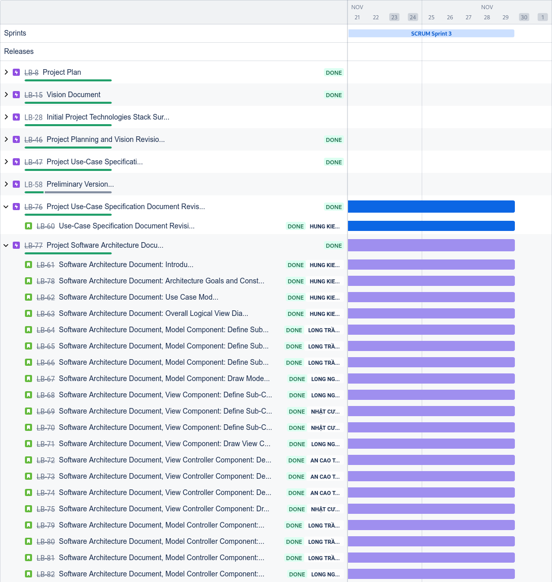

**Status reports:**

* Ngũ Kiệt Hùng
  + Completed tasks
    - *Software Architecture Document:* Overall Diagram of Logical View of system architecture components and main cross-component communication methods based on Model-View-Controller.
  + To-do tasks
    - Prepares for PA4
  + Issues/Obstacles: None
* Trình Cao An
  + Completed tasks: None
  + To-do tasks
    - Prepares for PA4
  + Issues/Obstacles: None
* Trần Thanh Long
  + Completed tasks
    - *Software Architecturing, Model Controller Component*: Define Use Cases as Sub-Components.
    - *Software Architecturing, Model Controller Component*: Define Components Responsibility.
    - *Software Architecturing, Model Controller Component*: Define Components inner references and outer references.
  + To-do tasks
    - Prepares for PA4
  + Issues/Obstacles: None
* Trần Nguyễn Nhật Cường
  + Completed tasks
    - *Software Architecturing, View Component:* Define Sub-Components Responsibility.
    - *Software Architecturing, View Component:* Define Sub-Components References.
    - *Software Architecturing, Controller Component*: Draw Controller Component Class Diagrams.
  + To-do tasks
    - Prepares for PA4
  + Issues/Obstacles: None
* Nguyễn Thế Thanh Long
  + Completed tasks
    - *Software Architecturing, View Component:* Define the Primary Views.
    - *Software Architecturing, View Component:* Draw View Component Class Diagrams according to specified format.
    - *Software Architecturing, Model Component*: Draw Model Component Class Diagrams.
  + To-do tasks
    - Prepares for PA4
  + Issues/Obstacles

**Actions:** Preparation for PA4 tasks is undergoing. The team has decided on a major shift in software technology; going from Oat++ to using Spring Framework as our Back-end technology.

**Summary of the meeting:** the meeting has been conducted in order to evaluate the proficiency of each team member during heavy workloads. The evaluation has proven to be successful and lead to the re-completion of PA3-related documentation as well as all required documentation of PA4. No notable challenges were found within this week's work, but the team will keep on monitoring for future schedule crossings.

=========== 27/11, Sprint 3, First Week Report ===============

**Time:** 19:43

**Team members present:**

* Trình Cao An
* Trần Thanh Long
* Nguyễn Thế Thanh Long
* Trần Nguyễn Nhật Cường
* Ngũ Kiệt Hùng

**Team members absent: None**

**JIRA status:**

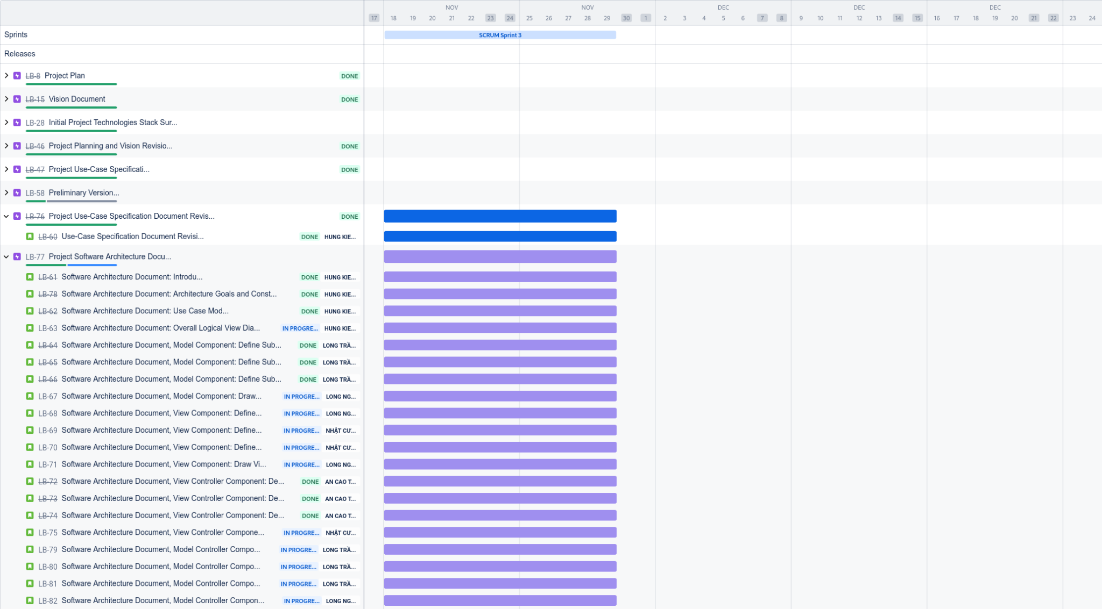

**Status reports:**

* Ngũ Kiệt Hùng
  + Completed tasks
    - Project Use Case Specification review and correction based on stakeholder’s feedback.
    - *Software Architecture Document:* Software Architecture Document introduction.
    - *Software Architecture Document:* Architectural Goals and Constraints .
    - *Software Architecture Document:* Use Case Modeling.
  + To-do tasks
    - *Software Architecture Document:* Overall Diagram of Logical View of system architecture components and main cross-component communication methods based on Model-View-Controller.
  + Issues/Obstacles:
    - System Architecture is not yet clear any needs clarification/feedback directly from stakeholders.
* Trình Cao An
  + Completed tasks
    - *Software Architecturing, View Controller Component*: Define each Use Case as a Controller Sub-Component.
    - *Software Architecturing, View Controller Component*: Define Sub-Components Responsibility.
    - *Software Architecturing, View Controller Component*: Define Sub-Components
  + To-do tasks: None
  + Issues/Obstacles
    - System architecture changes rapidly, causing many re-specifications.
    - It is difficult to define controller classes and define its attributes and methods.
* Trần Thanh Long
  + Completed tasks
    - *Software Architecturing, Model Component*: Define Primary Data Classes that will exist in a system environment.
    - *Software Architecturing, Model Component*: Define Components Responsibility.
    - *Software Architecturing, Model Component*: Define Components inner references and outer references.
  + To-do tasks
    - *Software Architecturing, Model Controller Component*: Define Use Cases as Sub-Components.
    - *Software Architecturing, Model Controller Component*: Define Components Responsibility.
    - *Software Architecturing, Model Controller Component*: Define Components inner references and outer references.
  + Issues/Obstacles:
    - Multiple flaws and inconsistencies were discovered during checking of Long’s works.
* Trần Nguyễn Nhật Cường
  + Completed tasks: None
  + To-do tasks
    - *Software Architecturing, View Component:* Define Sub-Components Responsibility.
    - *Software Architecturing, View Component:* Define Sub-Components References.
    - *Software Architecturing, Controller Component*: Draw Controller Component Class Diagrams.
  + Issues/Obstacles
    - Deadlines from other courses hinders Cường’s ability to complete his task. Despites that, Cường's has ensured his completion will be on-time.
* Nguyễn Thế Thanh Long
  + Completed tasks: None
  + To-do tasks
    - *Software Architecturing, View Component:* Define the Primary Views.
    - *Software Architecturing, View Component:* Draw View Component Class Diagrams according to specified format.
    - *Software Architecturing, Model Component*: Draw Model Component Class Diagrams.
  + Issues/Obstacles : None

**Actions:** Although the tasks allocation was late, three of the five team members have started and gained progress in this current Spring. Despite that, multiple flaws were found within works and the team has consulted stakeholders for additional feedback, as well as setting higher standards for work submission.

**Summary of the meeting:** the meeting has found progress in the Sprint’s timeline. Although the progress is still not aligned with what management has planned, it is still in an acceptable range for which members who have not submitted their work have ensured it will be done. Along with that, team members have discussed numerous architectural patterns and have concluded on the Model-View-Controller pattern which fits nicely with the current system of LogBlock.

=========== 16/11, Sprint 2, Second Week Report ===============

**Time:** 20:32

**Team members present:**

* Ngũ Kiệt Hùng
* Trình Cao An
* Trần Thanh Long
* Nguyễn Thế Thanh Long
* Trần Nguyễn Nhật Cường

**Team members absent:** None

**JIRA status:**

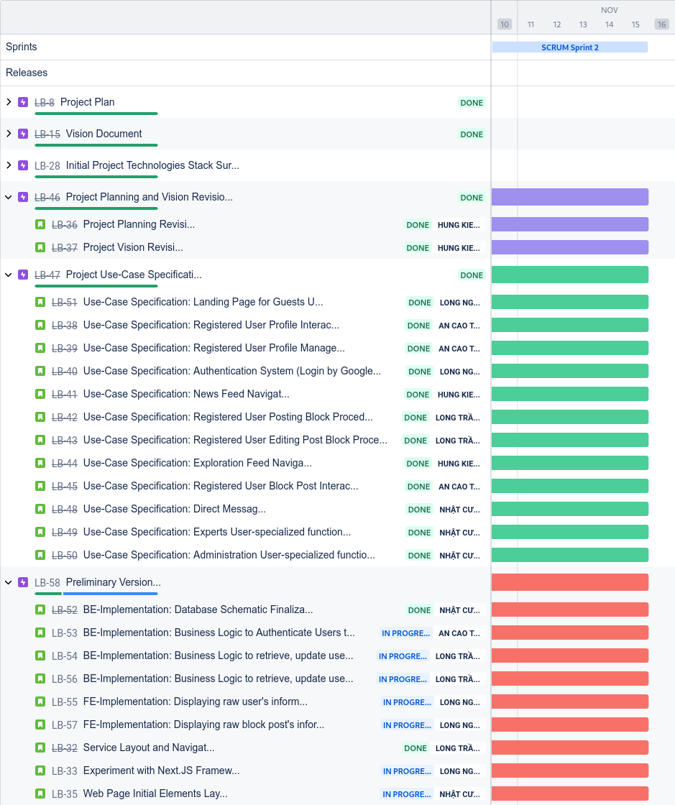

**Status reports:**

* Ngũ Kiệt Hùng
  + Completed tasks
    - *Use-Case Specification:* News Feed Navigation finished.
    - *Use-Case Specification:* Exploration Feed Navigation finished.
  + To-do tasks
    - Planning for PA3.
    - Preliminary Version implementation planning.
* Trình Cao An
  + Completed tasks
    - All primary tasks have been completed in the previous week.
  + To-do tasks
    - Continue preliminary version prototyping.
    - Preview PA3.
  + Issues/Obstacles
    - Not everyone is already completed in their tasks, resulting in wasted waiting time.
* Trần Thanh Long
  + Completed tasks
    - *Use-Case Specification:* Registered User Block Posting Procedure finished.
    - *Use-Case Specification:* Registered User Editing Block Post Procedure finished.
  + To-do tasks
    - Oral task: Database Implementation.
    - Preview PA3.
  + Issues/Obstacles
    - Issues with setting up PostgreSQL running environment.
    - PostgreSQL's official example seems to be wrong or outdated, resulting in wasted time.
* Trần Nguyễn Nhật Cường
  + Completed tasks
    - *Use-Case Specification:* Expert Users specialized functionalities finished.
    - *Use-Case Specification:* Administration User specialized functionalities finished.
    - *Use-Case Specification:* Direct Messaging finished.
    - Finalized database schematic.
  + To-do tasks
    - Review all Use Case Specifications documentation of all other members.
    - Continue with User Interface designing (From PA0).
    - Preview PA3.
* Nguyễn Thế Thanh Long
  + Completed tasks
    - *Use-Case Specification:* Landing Page for Guest Users finished.
    - *Use-Case Specification:* Authentication System finished.
    - Off-time collaboration with Cường to come up with more elegant designs for User Interface.
  + To-do tasks
    - Preview PA3.

**Actions:** The meeting has concluded that a reasonable performance was met by team members. The resulting deliverables are in acceptable condition, and Hùng will package it for delivery to stakeholders.

**Summary of the meeting:** The meeting aim is to evaluate the progress in software requirement design of team members; as well as evaluating completion time of each individual. With those targets in mind, the meeting chair has concluded that the evaluation is successful, but not yet outstanding due to not being able to conduct optional implementation tasks.

=========== 09/11, Sprint 2, First Week Report ===============

**Time:** 20:17

**Team members present:**

* Trình Cao An
* Trần Thanh Long
* Nguyễn Thế Thanh Long
* Trần Nguyễn Nhật Cường
* Ngũ Kiệt Hùng

**Team members absent: None**

**JIRA status:**

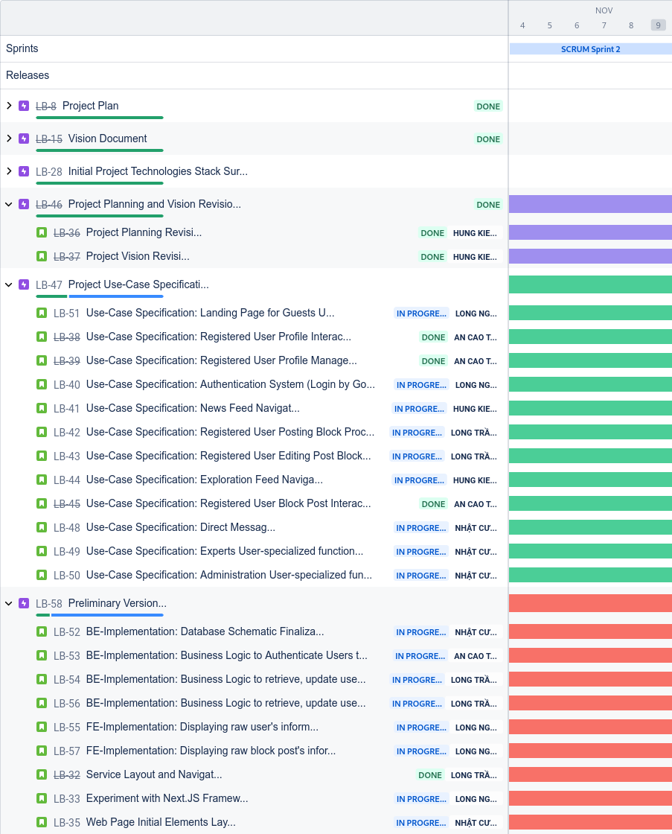

**Status reports:**

* Ngũ Kiệt Hùng
  + Completed tasks
    - Project planning and vision refinement based on stakeholder’s feedback.
  + To-do tasks
    - *Use-Case Specification:* News Feed Navigation and Diagram.
    - *Use-Case Specification:* Exploration Feed Navigation and Diagram.
  + Issues/Obstacles
    - Deadlines from other courses hinders the process.
    - Issues with Use Case Diagram creation tool.
    - Reviewing feedback from stakeholders based on other groups' submissions.
* Trình Cao An
  + Completed tasks
    - *Use-Case Specification:* Registered User Profile Interaction finished.
    - *Use-Case Specification:* Registered User Profile Management finished.
    - *Use-Case Specification:* Registered Users Block Post Interaction finished.
  + To-do tasks
    - Survey Google Authentication Mechanism.
    - *Back-End Implementation:* User Authentication through Google Authentication.
    - Refine Use Case Diagram based on group’s feedback.
  + Issues/Obstacles
    - Implementation of Google Authentication (API workflow, ...) is not yet clear.
    - Tools to create Use Case Diagrams have not been standardized among the group.
* Trần Thanh Long
  + Completed tasks
    - System service layout and Pages Navigation.
  + To-do tasks
    - Since the timing budget is limited, Long must prioritize Use Case Specification tasks.
    - *Use-Case Specification:* Registered User Block Posting Procedure
    - *Use-Case Specification:* Registered User Editing Block Post Procedure
  + Issues/Obstacles
    - Deadlines from other courses have to be taken first.
    - Database schematic not finalized.
* Trần Nguyễn Nhật Cường
  + Completed tasks
    - *Use-Case Diagram:* Direct Messaging finished.
    - Next.JS Experiment and Demo.
  + To-do tasks
    - Since timing constraint is on the line, Cường will prioritize finishing Use Case Specification tasks.
    - *Use-Case Specification:* Direct Messaging.
    - *Use-Case Specification:* Expert Users specialized functionalities.
    - *Use-Case Specification:* Administration User specialized functionalities.
  + Issues/Obstacles
    - Database schematic not finalized.
* Nguyễn Thế Thanh Long
  + Completed tasks
    - *Use-Case Diagram:* Landing Page for Guest Users finished.
    - *Use-Case Diagram:* Authentication System finished.
  + To-do tasks
    - *Use-Case Specification:* Landing Page for Guest Users.
    - *Use-Case Specification:* Authentication System
  + Issues/Obstacles
    - Google Authentication mechanism is not well-understood, requiring further demonstration.
    - Unclear task description, leadings to only Use Case Diagram being drawn and Use Case Specification not written.

**Actions:** The group has confirmed that tasks progress is at acceptable velocity. Actions are taken to clarify tasks description and help establish a standardized structure for Use Case Specifications. The group has also chosen PostgreSQL as the main Database Management System.

**Summary of the meeting:** tasks progress tracking has proven to be more successful since the last sprint due to the recent changes, though it is noticeable that tasks allocation is still delayed due to Project Manager’s scheduling. The meeting has also concluded that due to timing constraints and the current progression, optional tasks are to be ignored temporarily and main focus should be on Use Case Specification tasks.

=========== 02/11, Sprint 1, Second Week Report ===============

**Time:** 20:16

**Team members present:**

* Ngũ Kiệt Hùng
* Trình Cao An
* Trần Thanh Long
* Nguyễn Thế Thanh Long
* Trần Nguyễn Nhật Cường

**Team members absent:** None

**JIRA status:**

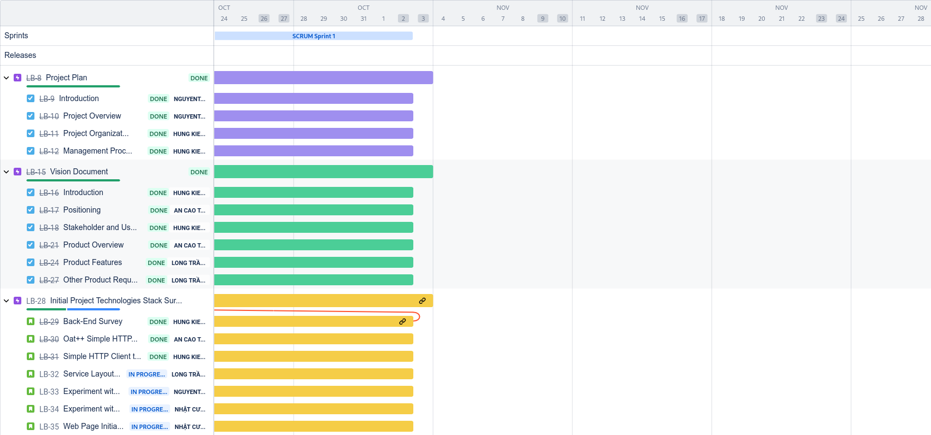

**Status reports:**

* Ngũ Kiệt Hùng
  + Completed tasks
    - Completed all initial project planning documentation and development team vision documentation
  + To-do tasks
    - Preparing for PA2 tasks
* Trình Cao An
  + Completed tasks
    - Oat++ web server demonstration
    - Project planning and vision refinement
  + To-do tasks
    - Preparing for PA2 tasks
  + Issues/Obstacles
    - Oat++ setup is primarily guided on Linux systems
    - Oat++ API documentation is not completed and obscured in some parts.
* Trần Thanh Long
  + Completed tasks
    - Project Plan quality assurance and correctness
    - Vision Document product-related descriptions
  + To-do tasks
    - Preparing for PA2 tasks
    - Continue service layout and navigation design
  + Issues/Obstacles
    - Figma unfamiliarity
    - Documentation content uncertainty
* Trần Nguyễn Nhật Cường
  + Completed tasks
    - Initial application layout including main pages, exploration search page and authentication page
    - Initial experimentation with Next.JS workflow
  + To-do tasks
    - Preparing for PA2 tasks
    - Continue with elements layout design and integration with Next.JS
* Nguyễn Thế Thanh Long
  + Completed tasks
    - Next.JS environment setting up
    - Next.JS React-based routing system
    - Experiment implementation of authentication page
  + To-do tasks
    - Preparing for PA2 tasks
    - Present findings with team on review meeting
  + Issues/Obstacles
    - JIRA technical error, leading to un-noticed task assignment

**Actions:** Project Management has received feedback from team members and will change the planning pipelines for future sprints.

**Summary of the meeting:** Most of the assigned tasks have been completed and quality assurance has been conducted to ensure correctness before delivering the final iteration product to stakeholders and users.

=========== 27/10, Sprint 1, First Week Report ===============

**Time:** 20:34

**Team members present:**

* Trình Cao An
* Trần Thanh Long
* Nguyễn Thế Thanh Long
* Trần Nguyễn Nhật Cường
* Ngũ Kiệt Hùng

**Team members absent:**

**Status reports:**

* Ngũ Kiệt Hùng
  + Completed tasks
    - Experiment with C++ back-end technologies
  + To-do tasks
    - Project Plan Document Initial version
    - Vision Document Initial version
* Trình Cao An
  + Completed tasks
    - Vision Document refining
  + To-do tasks
    - C++ back-end experiments
    - Simple HTTP Server for system structural planning
  + Issues/Obstacles
    - Waiting for finalization of back-end main framework
* Trần Thanh Long
  + Completed tasks
    - Project Plan correctness assurance
    - Vision Document correctness assurance
  + To-do tasks
    - Design Initial Layout and Service Navigation
* Trần Nguyễn Nhật Cường
  + Completed tasks
    - Experiment with NextJS framework + workflow
  + To-do tasks
    - Design Initial Layout and Service Navigation
* Nguyễn Thế Thanh Long
  + Completed tasks
    - Project Plan Document Initial version
    - Vision Document Initial version
  + To-do tasks
    - Experiment with NextJS framework + workflow

**Actions:** Hùng finalized Back-End framework with Oat++, all implementation personnel will be experimenting with the technologies.

**Summary of the meeting:** The meeting conducts a thorough review of team members’ first week of labor and concludes that the project progress is behind schedule and performance should be increased to meet demands.

**November 2nd, 2024 Edit:** Due to unnecessary circumstances, JIRA report of this week was not recorded.